

P3 File Format & Extract

This document describes the format of the P3 file generated by CardWorld Producer and contains an extract from a sample file.

Version: 1.3

- P3 File
When CardWorld Producer (CWP) is used to issue EMV cards, it must be supplemented with an EMV data preparation system (e.g. Thales P3) and a chip card personalisation system (e.g. Datacard Smart Card Personalisation Manager) to complete the card production cycle.
When used for EMV card production, CWP generates an output file that is suitable for use as input into a Thales P3 EMV Data Preparation system. The CWP output file is known as the P3 file.

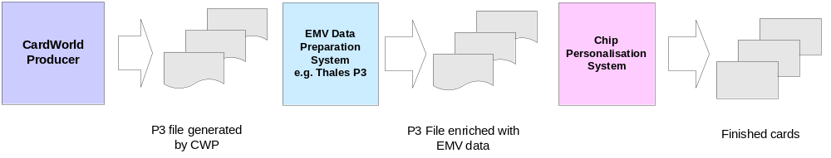
The P3 file produced by CWP contains the EMV card’s security data, track data, embossing data, basic chip data and PIN mailer data. This file is imported into the Thales P3 EMV data preparation system to enrich the basic chip data with the EMV parameter values that the bank wishes to apply. The enriched P3 file is then used as input to the chip card personalisation system.

The P3 file consists of a series of records, one for each EMV card in the production batch. Each record contains elements for the embossing data, track 1 & 2 magnetic stripe data, carrier data and chip data.

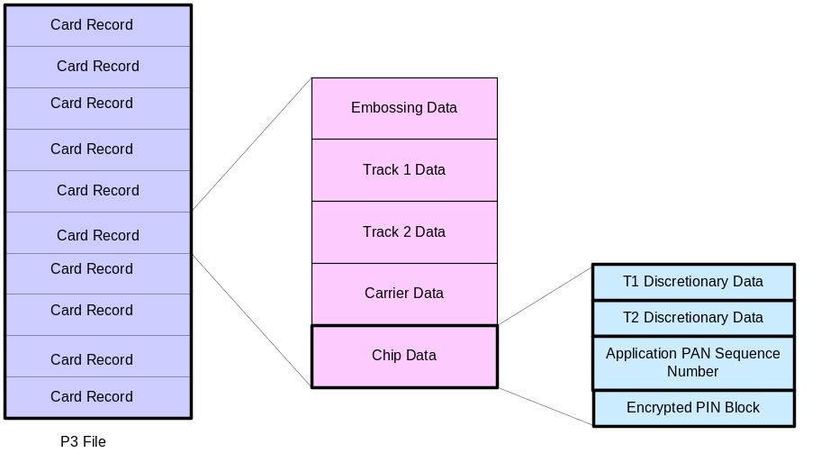

Note:
- The format of the P3 file assumes that EMV data preparation will be carried out by a Thales P3 system and that chip card personalisation will be performed by either Datacard 9000/7000 or a Datacard desktop embosser driven by Datacard SCPM software.

- The Zone Master Key and Terminal Pin Key must be shared between the Issuer system, CWP and Thales P3 system.
Each record in the P3 file contains the following elements:

 | Description | Notes
999999 | Record number | Each card record starts with a six digit number. e.g. 000001
$ | Embossing data | Data to be embossed on the card. The format is controlled by layout configuration of the CWP card type driver and a template file.
“ | Magnetic Stripe Data | Track 1 and Track 2 only.
| | Carrier Data | Address data for printing card carrier letter, formatted according to DataCard 9000/7000 spec.
{ | Chip Data | EMV parameters in TLV encoding. CWP supplies the encrypted PIN block and optionally track 1 discretionary data, track 2 discretionary data & application PAN sequence number.
#END# | Record end | This character sequence is used to mark the end of a card record.

Track data is indicated using the start and end sentinels. These are denoted as:

Track | Start Sentinel | End Sentinel
1 | “ | ?
2 | ; | ?

  - Track Data
The magnetic stripe data follows the format described in the VISA specification “Payment Technology Standards Manual”. The track formats are summarised in the tables below.

Track 1 Record Format:

Field Number | Length | Field Name | Character Code
1 | 1 | Start Sentinel | %
2 | 1 | Format Code | B
3 | 12-19 | Primary Account Number (PAN) | Numerics
4 | 1 | Separator | ^
5 | 2-26 | Cardholder Name | Alphanumerics
6 | 1 | Separator | ^
7 | 4 | Card Expiration Date (YYMM) | Numerics
8 | 3 | Service Code | Numerics
9 | 0 or 5 | PIN Verification Information:  Position: Length:  PVKI 1 1  PVV 2-5 4 | Numerics
10 | 8-10 | Discretionary Data | Alphanumerics
11 | 11 | Visa Reserved:  Position: Length:  CVV 3-5 3  ACI 8 1  All other positions are zero filled. | Alphanumerics
12 | 1 | End Sentinel | ?
13 | 1 | Longitudinal Redundancy Check

Track 2 Record Format:

Field Number | Length | Field Name | Character Code
1 | 1 | Start Sentinel | ;
2 | 12-19 | Primary Account Number (PAN) | Numerics
3 | 1 | Separator | =
4 | 4 | Card Expiration Date (YYMM) | Numerics
5 | 3 | Service Code | Numerics
6 | 0 or 5 | PIN Verification Information:  Position: Length:  PVKI 1 1  PVV 2-5 4 | Numerics
7 | 17 | Discretionary Data  Includes 3 digit CVV or iCVV | Numerics
8 | 1 | End Sentinel | ?
9 | 1 | Longitudinal Redundancy Check

  - Chip Data
CWP writes out the chip data in BER-TLV format with the following tags:

TAG | Description
9F 1F | Track 1 discretionary data, with CVV replaced by iCVV
57 | Track 2 discretionary data, with CVV replaced by iCVV
5F 34 | Application PAN Sequence Number
DF 01 | Encrypted PIN Block

All other EMV parameters in the chip data element are provided by the Thales P3 Data Preparation system.

- P3 Sample File
An extract from a P3 file containing the data for a single card is shown below:
00000000 30 30 30 30 30 31 24 4c 69 6e 65 31 20 34 31 32 |000001$Line1 412|
00000010 33 20 34 33 35 30 20 30 36 30 30 20 30 30 34 32 |3 4350 0600 0042|
00000020 20 4c 69 6e 65 32 20 31 32 2f 31 35 20 4c 69 6e | Line2 12/15 Lin|
00000030 65 33 20 4d 52 20 54 45 53 54 20 43 41 52 44 20 |e3 MR TEST CARD |
00000040 20 4c 69 6e 65 34 20 30 31 31 31 30 30 35 34 31 | Line4 011100541|
00000050 34 30 30 30 20 4c 69 6e 65 35 20 30 30 34 32 20 |4000 Line5 0042 |
00000060 32 36 32 22 25 42 34 31 32 33 34 33 35 30 30 36 |262"%B4123435006|
00000070 30 30 30 30 34 32 5e 43 41 52 44 2f 54 45 53 54 |000042^CARD/TEST|
00000080 2e 4d 52 5e 31 35 31 32 32 32 36 31 33 31 36 30 |.MR^151222613160|
00000090 31 31 30 30 30 30 30 30 30 30 31 31 39 30 30 30 |1100000000119000|
000000a0 30 30 30 3f 3b 34 31 32 33 34 33 35 30 30 36 30 |000?;41234350060|
000000b0 30 30 30 34 32 3d 31 35 31 32 32 32 36 31 33 31 |00042=1512226131|
000000c0 36 30 31 31 39 31 31 3f 7c 34 31 32 33 34 33 35 |6011911?|4123435|
000000d0 30 30 36 30 30 30 30 34 32 5f 56 5f 31 7c 31 7c |006000042_V_1|1||
000000e0 7c 7c 30 30 30 30 30 31 7c 30 31 31 31 30 30 35 |||000001|0111005|
000000f0 34 31 34 30 30 30 7c 4d 52 20 54 65 73 74 20 43 |414000|MR Test C|
00000100 61 72 64 7c 30 31 30 31 31 30 7c 31 35 31 32 7c |ard|010110|1512||
00000110 56 7c 7c 43 52 32 20 48 4f 55 53 45 7c 4a 4f 59 |V||CR2 HOUSE|JOY|
00000120 43 45 20 57 41 59 7c 44 55 42 4c 49 4e 7c 49 45 |CE WAY|DUBLIN|IE|
00000130 7c 7c 7c 7c 7c 7c 7c 7c 7c 7c 7c 7c 7c 7c 7c 30 ||||||||||||||||0|
00000140 7c 7c 7c 7b 30 30 30 30 30 38 31 10 10 00 00 00 ||||{0000081.....|
00000150 4b 00 00 00 00 00 00 00 00 00 00 00 00 00 3d 9f |K.............=.|
00000160 1f 18 31 33 31 36 30 31 31 30 30 30 30 30 30 30 |..13160110000000|
00000170 30 33 38 31 30 30 30 30 30 30 57 11 41 23 43 50 |0381000000W.S.CP|
00000180 06 00 00 42 d1 51 22 26 13 16 03 81 11 5f 34 01 |...B.Q"&....._4.|
00000190 01 df 01 08 63 33 87 74 03 a7 fa 92 23 45 4e 44 |....c3.t....#END|
000001a0 23 |# |

The different types of data in the P3 file are shown in the following sections. The sample record starts with 000001 and ends with #END#.

  - Embossing Data
00000000 24 4c 69 6e 65 31 20 34 31 32 | $Line1 412|
00000010 33 20 34 33 35 30 20 30 36 30 30 20 30 30 34 32 |3 4350 0600 0042|
00000020 20 4c 69 6e 65 32 20 31 32 2f 31 35 20 4c 69 6e | Line2 12/15 Lin|
00000030 65 33 20 4d 52 20 54 45 53 54 20 43 41 52 44 20 |e3 MR TEST CARD |
00000040 20 4c 69 6e 65 34 20 30 31 31 31 30 30 35 34 31 | Line4 011100541|
00000050 34 30 30 30 20 4c 69 6e 65 35 20 30 30 34 32 20 |4000 Line5 0042 |
00000060 32 36 32 |262

  - Magnetic Stripe Data – Track 1
00000060 22 25 42 34 31 32 33 34 33 35 30 30 36 | "%B4123435006|
00000070 30 30 30 30 34 32 5e 43 41 52 44 2f 54 45 53 54 |000042^CARD/TEST|
00000080 2e 4d 52 5e 31 35 31 32 32 32 36 31 33 31 36 30 |.MR^151222613160|
00000090 31 31 30 30 30 30 30 30 30 30 31 31 39 30 30 30 |1100000000119000|
000000a0 30 30 30 3f 3b 34 31 32 33 34 33 35 30 30 36 30 |000? |

  - Magnetic Stripe Data – Track 2
000000a0 30 30 30 3f 3b 34 31 32 33 34 33 35 30 30 36 30 | ;41234350060|
000000b0 30 30 30 34 32 3d 31 35 31 32 32 32 36 31 33 31 |00042=1512226131|
000000c0 36 30 31 31 39 31 31 3f 7c 34 31 32 33 34 33 35 |6011911? |

  - Carrier Data
000000c0 7c 34 31 32 33 34 33 35 | |4123435|
000000d0 30 30 36 30 30 30 30 34 32 5f 56 5f 31 7c 31 7c |006000042_V_1|1||
000000e0 7c 7c 30 30 30 30 30 31 7c 30 31 31 31 30 30 35 |||000001|0111005|
000000f0 34 31 34 30 30 30 7c 4d 52 20 54 65 73 74 20 43 |414000|MR Test C|
00000100 61 72 64 7c 30 31 30 31 31 30 7c 31 35 31 32 7c |ard|010110|1512||
00000110 56 7c 7c 43 52 32 20 48 4f 55 53 45 7c 4a 4f 59 |V||CR2 HOUSE|JOY|
00000120 43 45 20 57 41 59 7c 44 55 42 4c 49 4e 7c 49 45 |CE WAY|DUBLIN|IE|
00000130 7c 7c 7c 7c 7c 7c 7c 7c 7c 7c 7c 7c 7c 7c 7c 30 ||||||||||||||||0|
00000140 7c 7c 7c |||| |

  - Basic Chip Data

00000140 7b 30 30 30 30 30 38 31 10 10 00 00 00 | {0000081.....|
00000150 4b 00 00 00 00 00 00 00 00 00 00 00 00 00 3d 9f |K.............=.|
00000160 1f 18 31 33 31 36 30 31 31 30 30 30 30 30 30 30 |..13160110000000|
00000170 30 33 38 31 30 30 30 30 30 30 57 11 41 23 43 50 |0381000000W.S.CP|
00000180 06 00 00 42 d1 51 22 26 13 16 03 81 11 5f 34 01 |...B.Q"&....._4.|
00000190 01 df 01 08 63 33 87 74 03 a7 fa 92 |....c3.t.... |

In the above extract, BER-TLV tags for T1 discretionary data, T2 discretionary data, APSN and PIN block are shown highlighted in yellow. The Tag 9F 1F data and Tag 57 data contain iCVV in place of CVV.

